Surface Area and Volume Name: ____________________________
Math 3

Directions: Find each of the following. Show all work to receive credit.

- Determine the perimeter of the largest rectangular Cola advertisement in central Sydney. It has an area of 90 m² and side length of 10 m.

- Find the total surface area of the prism shown.
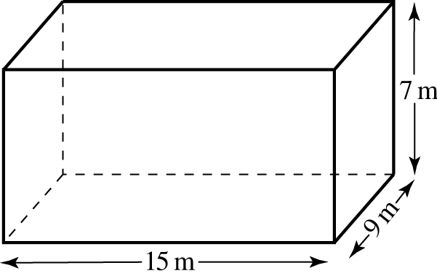

- Find the volume of the triangular prism shown.
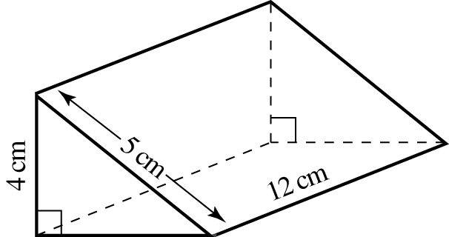

- A metal rubbish bin is cylindrical in design with one end opened. Using the dimensions shown on the diagram, calculate the total surface area (TSA) of the metal used to the nearest cm².
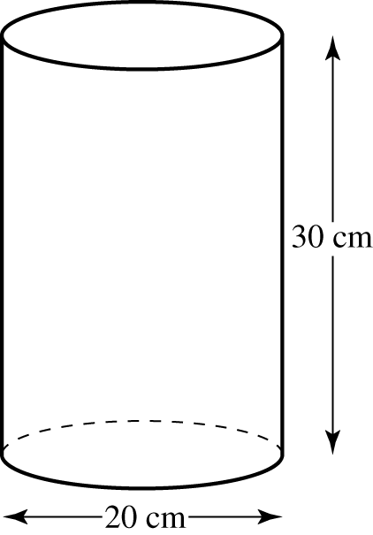

- A tennis ball has a surface area of 160 cm². Determine whether it will fit through a circular hole with a diameter of 6.5 cm.

- Find the area of the shaded part in the diagram below.
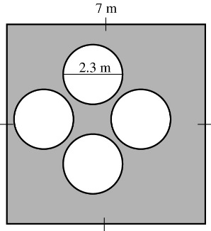

- Find the total surface area (TSA) of the triangular prism to the nearest cm².
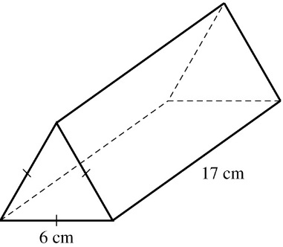

- Find the volume of the triangular prism shown.
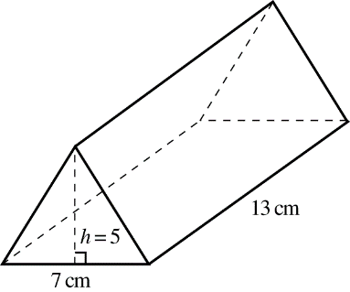

- A hemispherical bowl with a diameter of 70 cm is used to hold a pre-mixed fruit drink for a party. If you want to fill it to the brim, how many liters of pre-mixed drink can you fill in? Give your answer to the nearest liter.

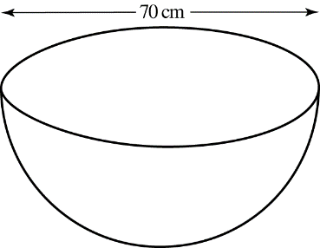

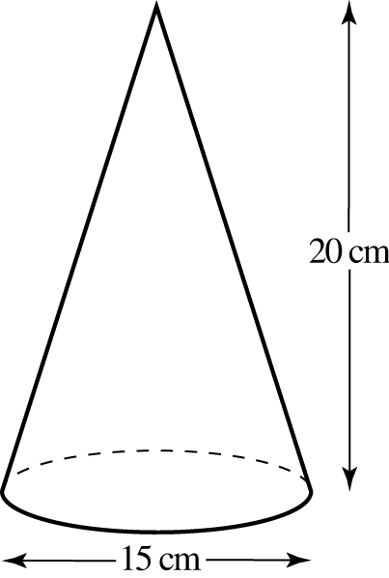
- Find the volume of the cone with a diameter of 15 cm and height of 20 cm to the nearest cm³.

