Quiz Review: Piecewise, and Absolute Value
Graph the piecewise functions:
1. 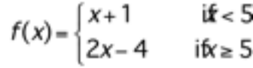

2.

3. 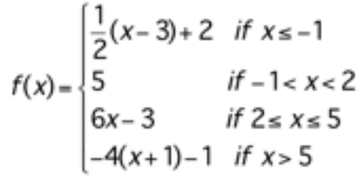
Evaluate the following:
- f(-1)

- f(1)

- f(5)

- f(7)

4. Write the piecewise functions for the graphs shown.
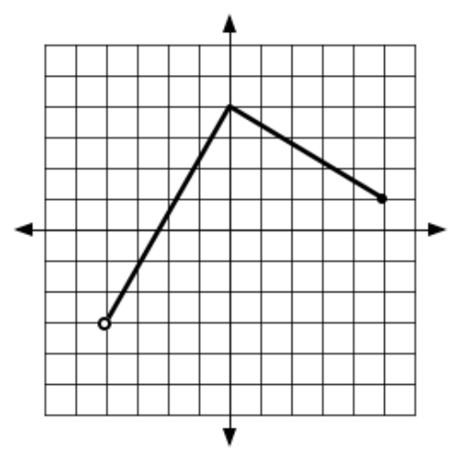
a.

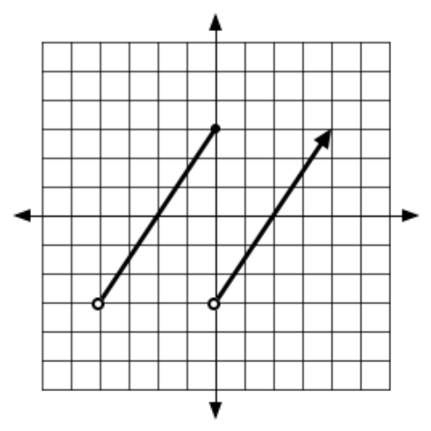

b.

5. Solve for x. Be sure to find all solutions. Some x values will be fractional.
a. 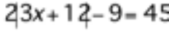 b. 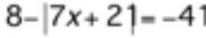

c. 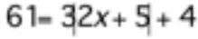 d. 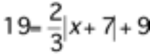

6. Write an absolute value formula and a piecewise formula for the following graph:
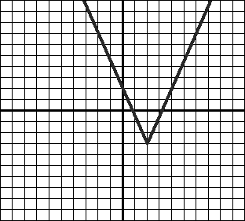

7. Graph the following absolute value function and find the vertex and x- and y-intercepts:
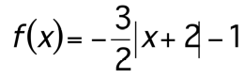
Vertex:
y-intercept:
x-intercept:

8. 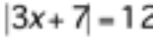

9. 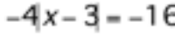

10. 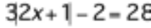

11. 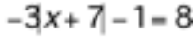

12. 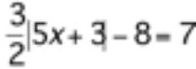

ANSWERS:
1. 2.
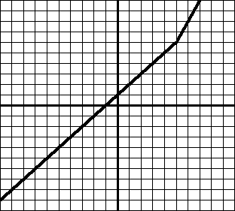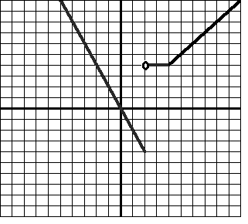
3. a. f(-1) = 0 b. f(1) = 5 c. f(5) = 27 d. f(7) = -33
- a. b.
- a. 5 and –13 b. 47/7 and –51/7 c. 7 and –12 d. 22 and –8
- 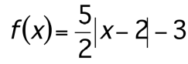 and
7.
. 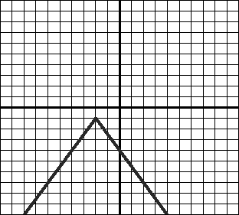
Vertex: (–2, –1) Y-intercept: –4, No x-intercepts.

8. 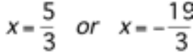 9. 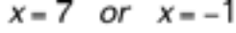

10. 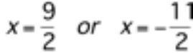 11. No Solution

12. 

