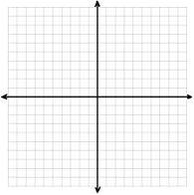

**Transformations**

y = -a |x – h| + k

Example 1 – Identify the transformations:

1. y = 3 |x + 2| - 3
2. y = |x – 1| + 2
3. y = 2 |x + 3| - 1
4. y = -1/3|x – 2| + 1

Example 2



1. Graph y = |x| (the parent function)
2. Graph y = -2 |x + 3| + 2

* What is your vertex?
* What are the intercepts?

Example 3 – Write the functions for these graphs.

