- Adding, Subtracting, and Multiplying monomials and binomials and trinomials.
- $2x\left(3x+1\right)$

- $\left(3x-1\right)\left(x+2\right)$

- $2x(x^{2}+3x-1)$

- $Add:\left(4x+10\right)+\left(3x-2\right)$

- Subtract: $\left(6x-3\right)-(2x+5)$

- Multiplying Special cases.
- Perfect square trinomial; ${\left(x+2\right)}^{2}$

- Difference of squares; $\left(x-4\right)\left(x+4\right)$

- Factoring
- Using GCF, factor: $6x^{2}+18x$

- Using Simple factoring (big X), factor: $x^{2}+5x+6$

- Using X-box, factor: $2x^{2}+13x+15$

- Using Complete the square – find “c” and rewrite as factors: $x^{2}+8x+c$

- Solving Quadratics equations
- Using GCF solve: $3x^{2}-18x=0$

- By taking square root, solve: $4x^{2}=49$

- Using Zero-product property, solve: $\left(x-3\right)\left(2x+7\right)=0$

- Using Simple Factoring, solve $x^{2}-x-6=0$

- Using X-box, solve $y=3x^{2}-8x+4$

- Using the Quadratic formula, solve $y=2x^{2}+3x-5$

- Graphing quadratic equations
- Find the vertex, y-intercept, and roots, and graph $y=x^{2}-3x-10$
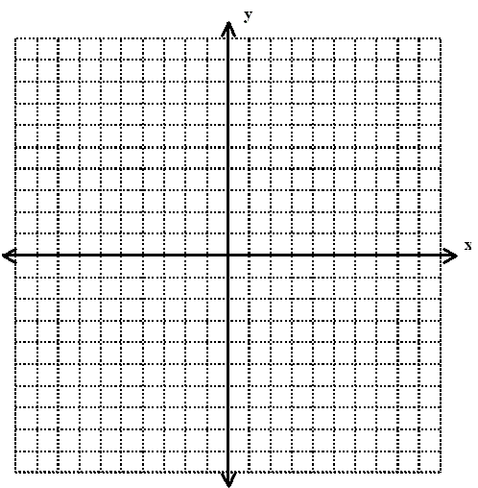

- Transforms with quadratic graphs
Parent Function: $y=x^{2}$
$$y=a{\left(x-h\right)}^{2}+k$$

- $y=2x^{2}-3$ | - $y=-2{\left(x-1\right)}^{2}$
- $y={\left(x+1\right)}^{2}+5$ | - $y=5{\left(x+2\right)}^{2}-3$
- $y=x^{2}+3$ | - $y=-{\left(x+2\right)}^{2}+4$

- If $a>0$the graph opens ________________
- If $a<0$ the graph opens ________________
- If $h>0$ the graph slides ________________
- $if h<0$the graph slides ________________
- If $k>0$ the graph slides ________________
- $if k<0$the graph slides ________________

- Solving systems of quadratic and linear equations.
- $y=x^{2}-9x+18 and y=4x-12$

- $y=x^{2}+6x+3 and y=3x-7$

Applications
- Find the maximum height of a baseball that follows the path modeled by the equations $h\left(t\right)=-16t^{2}+32t+6.$

- Using the same equation above, how many seconds after the ball is hit does it land on the ground?

- Complex numbers.
- Add: $\left(3-4i\right)+\left(2-6i\right)$

- Subtract: $\left(10+6i\right)-\left(3+2i\right)$

- Solve the equation by taking square root: $x^{2}+49=0$

