AP Calculus BC

Logistics Functions

Name: _______________________________________ Date: __________________

Show full solutions to each of the following. Do your work on separate paper. Attach it to this sheet. Turn it in by the end of the period.

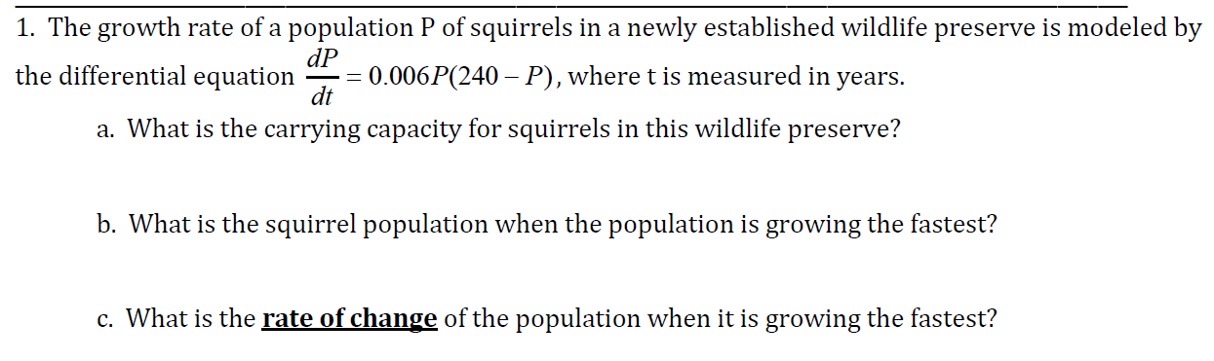

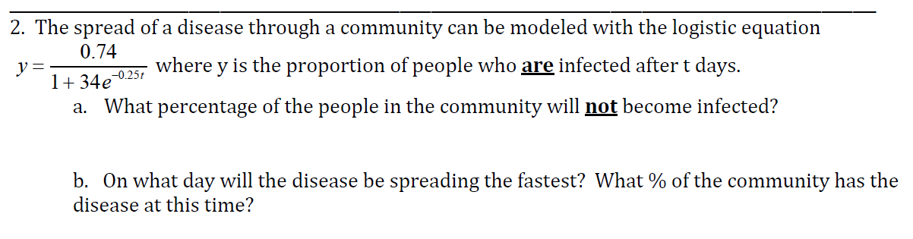

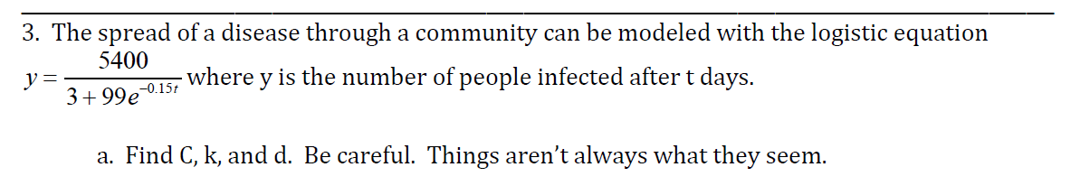

Note: Assume the function is of the form 



