Trapezoids [65 marks]
1a. [2 marks]
The cross-sectional view of a tunnel is shown on the axes below. The line $\left[AB\right]$ represents a vertical wall located at the left side of the tunnel. The height, in metres, of the tunnel above the horizontal ground is modelled by $y=−0.1x^{3}+ 0.8x^{2}, 2≤x≤8$, relative to an origin $O$.
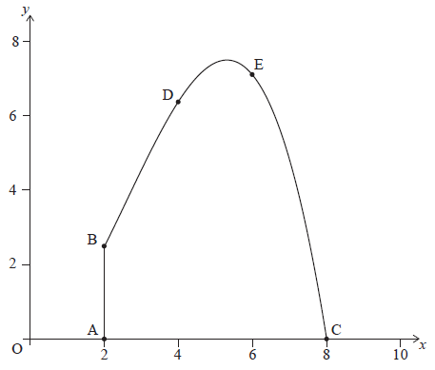
Point $A$ has coordinates $\left(2, 0\right)$, point $B$ has coordinates $\left(2, 2.4\right)$, and point $C$ has coordinates $\left(8, 0\right)$.
When $x=4$ the height of the tunnel is $6.4 m$ and when $x=6$ the height of the tunnel is $7.2 m$. These points are shown as $D$ and $E$ on the diagram, respectively.
Write down the integral which can be used to find the cross-sectional area of the tunnel.
1b. [2 marks]
Hence find the cross-sectional area of the tunnel.
2a. [3 marks]
A function $f$ is given by $f(x)=4x^{3}+\frac{3}{x^{2}}−3, x≠0$.
Write down the derivative of $f$.
2b. [3 marks]
Find the point on the graph of $f$ at which the gradient of the tangent is equal to 6.
3a. [2 marks]
The following diagram shows part of the graph of $f(x)=\left(6−3x\right)\left(4+x\right)$, $x∈R$. The shaded region R is bounded by the $x$-axis, $y$-axis and the graph of $f$.
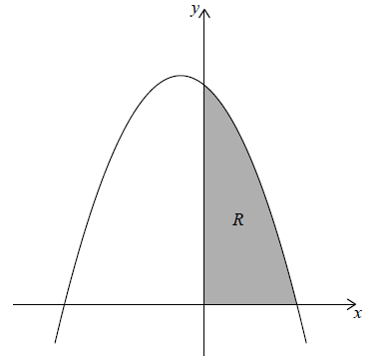
Write down an integral for the area of region R.
3b. [1 mark]
Find the area of region R.
3c. [2 marks]
The three points A(0, 0) , B(3, 10) and C($a$, 0) define the vertices of a triangle.
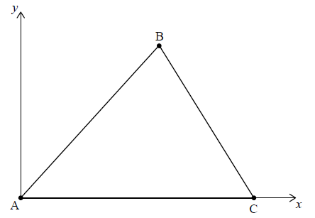
Find the value of $a$, the $x$-coordinate of C, such that the area of the triangle is equal to the area of region R.
4a. [1 mark]
Consider the curve $y=x^{2}−4x+2$.
Find an expression for $\frac{dy}{dx}$.
4b. [6 marks]
Show that the normal to the curve at the point where $x=1$ is $2y−x+3=0$.
5a. [1 mark]
The diagram shows the curve $y=\frac{x^{2}}{2}+\frac{2a}{x}, x≠0$.
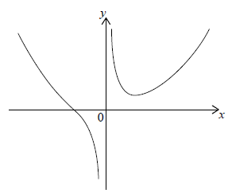
The equation of the vertical asymptote of the curve is $x=k$.
Write down the value of $k$.
5b. [3 marks]
Find $\frac{dy}{dx}$.
5c. [2 marks]
At the point where $x=2$, the gradient of the tangent to the curve is $0.5$.
Find the value of $a$.
6a. [5 marks]
The function $f\left(x\right)=\frac{1}{3}x^{3}+\frac{1}{2}x^{2}+kx+5$ has a local maximum and a local minimum. The local maximum is at $x=−3$.
Show that $k=−6$.
6b. [2 marks]
Find the coordinates of the local minimum.
6c. [2 marks]
Write down the interval where the gradient of the graph of $f\left(x\right)$ is negative.
6d. [5 marks]
Determine the equation of the normal at $x=−2$ in the form $y=mx+c$.
7a. [2 marks]
Consider the curve y = 5x³ − 3x.
Find $\frac{dy}{dx}$.
7b. [2 marks]
The curve has a tangent at the point P(−1, −2).
Find the gradient of this tangent at point P.
7c. [2 marks]
Find the equation of this tangent. Give your answer in the form y = mx + c.
8a. [2 marks]
Let $f\left(x\right)=6x^{2}−3x$. The graph of $f$ is shown in the following diagram.
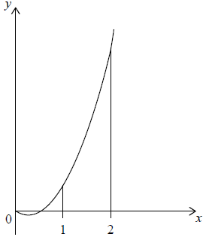
Find $∫\left(6x^{2}−3x\right)dx$.
8b. [4 marks]
Find the area of the region enclosed by the graph of $f$, the x-axis and the lines x = 1 and x = 2 .
9a. [4 marks]
Consider the curve y = 2x³ − 9x² + 12x + 2, for −1 < x < 3
Sketch the curve for −1 < x < 3 and −2 < y < 12.
9b. [1 mark]
A teacher asks her students to make some observations about the curve.
Three students responded.
Nadia said “The x-intercept of the curve is between −1 and zero”.
Rick said “The curve is decreasing when x < 1 ”.
Paula said “The gradient of the curve is less than zero between x = 1 and x = 2 ”.
State the name of the student who made an incorrect observation.
9c. [3 marks]
Find $\frac{dy}{dx}$.
9d. [3 marks]
Given that y = 2x³ − 9x² + 12x + 2 = k has three solutions, find the possible values of k.

Printed for GARNER MAGNET HIGH SCH
© International Baccalaureate Organization 2022
International Baccalaureate® - Baccalauréat International® - Bachillerato Internacional®

