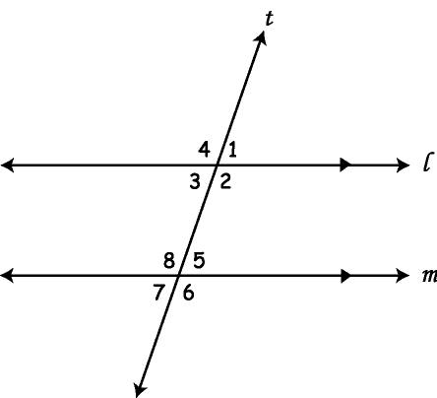Parallel Lines and Transversals

Parallel Lines Conjecture -

**Corresponding Angles Conjecture:** If 2 parallel lines are cut by a transversal, then

**Same-Side Interior Angles Conjecture:**

**Same-Side Exterior Angles Conjecture:**

**Alternate Interior Angles Conjecture:**

**Alternate Exterior Angles Conjecture:**

*Examples* *(treat each example independently)*

1. If m1 = 58°, find m5.
2. If m8 = 106°, find m2.
3. If m1 = 67°, find m6.

4) If m1 = 3x + 7 and m5 = 4x – 10, find m1.

5) If m1 = 47°, find the measures of

all other angles.

m2 = _________ m6 = _________

m3 = _________ m7 = _________

m4 = _________ m8 = _________

m5 = _________